Output

|  | **Age** | **Gender** | **Stream** | **Internships** | **CGPA** | **Hostel** | **HistoryOfBacklogs** | **PlacedOrNot** |
| --- | --- | --- | --- | --- | --- | --- | --- | --- |
| **0** | 22 | Male | Electronics And Communication | 1 | 8 | 1 | 1 | 1 |
| **1** | 21 | Female | Computer Science | 0 | 7 | 1 | 1 | 1 |
| **2** | 22 | Female | Information Technology | 1 | 6 | 0 | 0 | 1 |
| **3** | 21 | Male | Information Technology | 0 | 8 | 0 | 1 | 1 |
| **4** | 22 | Male | Mechanical | 0 | 8 | 1 | 0 | 1 |

(2966, 8)

Index(['Age', 'Gender', 'Stream', 'Internships', 'CGPA', 'Hostel', 'HistoryOfBacklogs', 'PlacedOrNot'], dtype='object')

1829

Age 0

Gender 0

Stream 0

Internships 0

CGPA 0

Hostel 0

HistoryOfBacklogs 0

PlacedOrNot 0

dtype: int64

<class 'pandas.core.frame.DataFrame'>

RangeIndex: 2966 entries, 0 to 2965

Data columns (total 8 columns):

# Column Non-Null Count Dtype

--- ------ -------------- -----

0 Age 2966 non-null int64

1 Gender 2966 non-null object

2 Stream 2966 non-null object

3 Internships 2966 non-null int64

4 CGPA 2966 non-null int64

5 Hostel 2966 non-null int64

6 HistoryOfBacklogs 2966 non-null int64

7 PlacedOrNot 2966 non-null int64

dtypes: int64(6), object(2)

memory usage: 185.5+ KB

|  | **Age** | **Internships** | **CGPA** | **Hostel** | **HistoryOfBacklogs** | **PlacedOrNot** |
| --- | --- | --- | --- | --- | --- | --- |
| **count** | 2966.000000 | 2966.000000 | 2966.000000 | 2966.000000 | 2966.000000 | 2966.000000 |
| **mean** | 21.485840 | 0.703641 | 7.073837 | 0.269049 | 0.192178 | 0.552596 |
| **std** | 1.324933 | 0.740197 | 0.967748 | 0.443540 | 0.394079 | 0.497310 |
| **min** | 19.000000 | 0.000000 | 5.000000 | 0.000000 | 0.000000 | 0.000000 |
| **25%** | 21.000000 | 0.000000 | 6.000000 | 0.000000 | 0.000000 | 0.000000 |
| **50%** | 21.000000 | 1.000000 | 7.000000 | 0.000000 | 0.000000 | 1.000000 |
| **75%** | 22.000000 | 1.000000 | 8.000000 | 1.000000 | 0.000000 | 1.000000 |
| **max** | 30.000000 | 3.000000 | 9.000000 | 1.000000 | 1.000000 | 1.000000 |

Age 11

Gender 2

Stream 6

Internships 4

CGPA 5

Hostel 2

HistoryOfBacklogs 2

PlacedOrNot 2

dtype: int64

array([22, 21, 23, 24, 28, 30, 25, 26, 20, 19, 29])

<AxesSubplot:xlabel='Age', ylabel='count'>

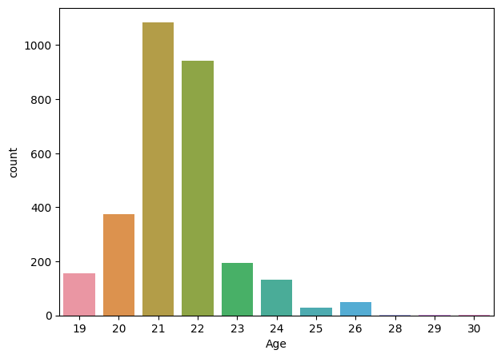

21 1084

22 941

20 375

23 195

19 156

24 131

26 50

25 29

28 3

30 1

29 1

Name: Age, dtype: int64

<Axes: xlabel='Internships', ylabel='PlacedOrNot'>

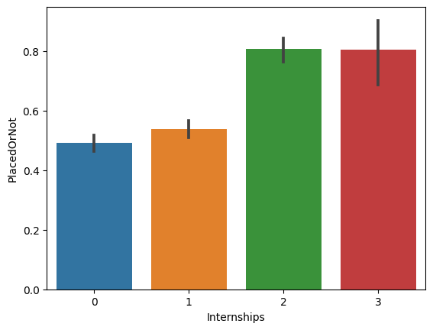

0 1331

1 1234

2 350

3 51

Name: Internships, dtype: int64

7 956

8 915

6 834

9 165

5 96

Name: CGPA, dtype: int64

<Axes: xlabel='CGPA', ylabel='PlacedOrNot'>

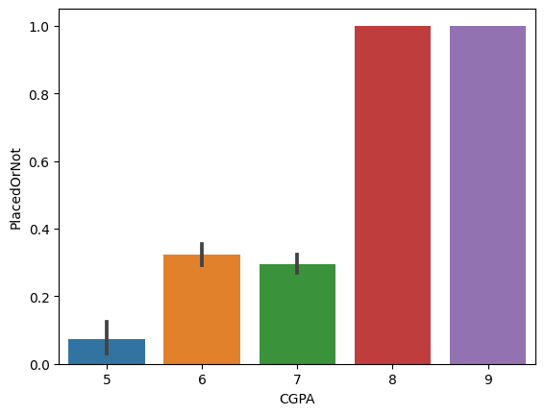

<Axes: xlabel='Hostel', ylabel='PlacedOrNot'>

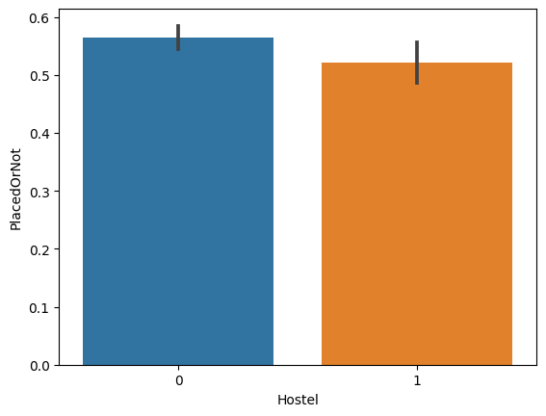

<Axes: xlabel='Gender', ylabel='PlacedOrNot'>

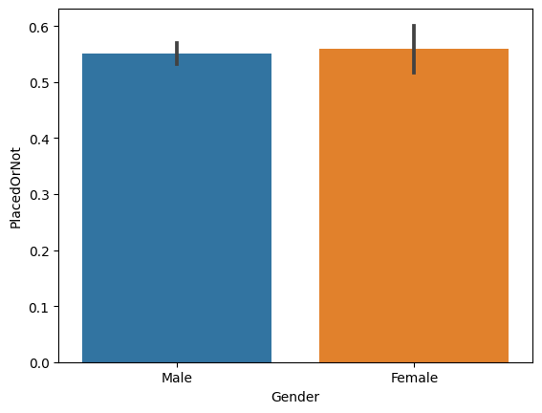

<Axes: xlabel='HistoryOfBacklogs', ylabel='PlacedOrNot'>

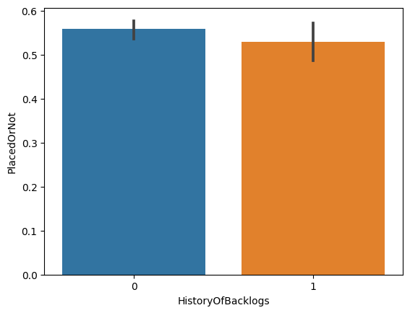

|  | **Age** | **Gender** | **Stream** | **Internships** | **CGPA** | **Hostel** | **HistoryOfBacklogs** | **PlacedOrNot** |
| --- | --- | --- | --- | --- | --- | --- | --- | --- |
| **0** | 22 | Male | Electronics And Communication | 1 | 8 | 1 | 1 | 1 |
| **1** | 21 | Female | Computer Science | 0 | 7 | 1 | 1 | 1 |
| **2** | 22 | Female | Information Technology | 1 | 6 | 0 | 0 | 1 |
| **3** | 21 | Male | Information Technology | 0 | 8 | 0 | 1 | 1 |
| **4** | 22 | Male | Mechanical | 0 | 8 | 1 | 0 | 1 |

array([0.73609707, 0.76238625, 0.84817814])

array([0.84428716, 0.84428716, 0.91396761])

array([0.71991911, 0.74823054, 0.83704453])

array([0.8463094 , 0.84934277, 0.88967611])

array([0.83013145, 0.81496461, 0.87246964])

RandomForestClassifier

RandomForestClassifier()

<Axes: >

